Reviewed arrangements
It is our plan that we reopen to all pupils in all year groups. To support with this, a thorough risk assessment has been written which includes 5 key sections:
- Prevention and response
- Operation of schools
- Curriculum, behaviour and pastoral support
- Assessment and accountability
- Contingency planning for outbreaks
All stakeholders must adhere to the guidance written within all 5 sections of the risk assessment.
This parent handbook provides additional information to support parents with the implementation of the risk assessment.
WHAT YOU NEED TO KNOW
Entrance/exit to school | - Your child is allocated an entrance, which will be either:  - Northwood Park road dropped off at Nursery black gate (Nursery)  - Northwood Park road dropped off at the lower black gate (Reception)  - Northwood Park road dropped off at the main upper black gate (Year 1 and Year 2)  The map below details these entrances.  - Parents / carers must drop their child off and leave immediately to allow for strict social distancing measures. Do not wait at the gates to wave to your child or stand in groups near the school  - Strictly one parent / carer only MUST accompany their child to and from school, no siblings unless absolutely necessary (if siblings accompany they must remain alongside the adult).  - Parents / carers to socially distance whilst they wait on the pavement outside school.  - Staff will guide children directly to their bubble classroom.  - If children arrive late, they must gain entry to the Academy via the main office as bubbles cannot mix.  - Face covering to be worn by all adults (unless exempt).  - Children will need to remove face coverings before entering the school. These are to be taken home by parents.  - Pupils must not bring their own hand sanitiser in from home.

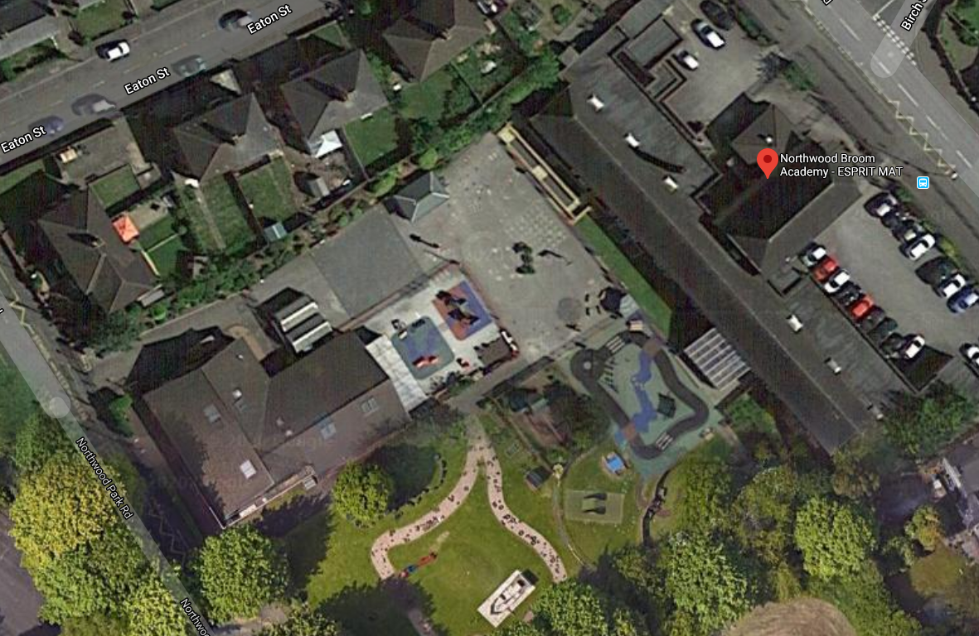
Main upper black gate
Nursery gate
Lower black gate
Groupings | - Children will be split into year group ‘bubbles’ and will not mix with any other bubble.  - Each bubble group will have 2 members of staff who will stay with the children in that bubble at all times.
BASC | - Before and After school provision (BASC) can be pre-booked at a cost for ALL PUPILS from the hours of 7.30am until 5:45pm.  - We offer this facility in conjunction with Grove Academy and children should be dropped off at Grove Academy Turner Street for Breakfast Club and then they will be safely escorted with our walking bus to Northwood Broom and their classroom  - In the afternoon, children will be collected from their classroom at Northwood Broom and will be safely escorted with our working bus to Grove Academy where they should be collected at the end of the after school session.  - Places MUST be booked 7 days in advance to allow for appropriate staffing and resources and places MUST be booked AND paid for via ParentPay  Breakfast Club  - 7:30am – start of school day £4.00  After School Club  - End of school day – 4:00pm £7.00  End of school day – 5:45pm £10.00

TIMETABLE & ARRANGEMENTS
 | Nursery Bubble | Reception Bubble | Year 1 Bubble | Year 2 Bubble
Arrival | 8.40am | 8.45am | 8.50am | 8.55am
Location | Dropped off at Nursery gate | Dropped off at lower black gate | Dropped off at Upper black gates. | Dropped off at Upper black gates.
Play time |  |  | 10.30am -10.45am | 10.45am -11.00am
Lunch time | 11.15-11.45am | 11.45-12.15 | 12.15-12.45 | 12.45-1.15
Structured play (PE) | 11.45 – 12.15pm | 12.15 -12.45 | 12.45 – 1.15 | 12.15-12.45
Dismissal | 11.40am part time children / 2.40pm full time children | 2.45pm | 2.50pm | 2.55pm
Location | Dismissed through the Nursery gate | Dismissed through the lower black gate | Dismissed through the Upper black gates | Dismissed through the Upper black gates

Clothing and belongings | - Children wear the Academy uniform as per the Uniform Policy (see website). Children can wear extra layers under or over their school uniform, including gilets and fleeces due to increased ventilation measures in place in the classrooms.  - Clothes must be clean on every day. If clothes do not appear clean, we will contact parents.  - Children must bring a water bottle every day, CLEARLY LABELLED with their name.  - Children must bring a box of tissues into school to be kept in their individual pack for their use only.  - If your child uses an inhaler, this must be brought to school and left in the child’s bubble classroom at the start of the academic year. A medical care plan must be completed before children bring this into school if they have not used one in school previously.  - Children are asked to bring a book bag to school and this will be kept in their individual tray.  - Children will require a PE kit in Key Stage 1. Teachers will let you know which day this will be on.
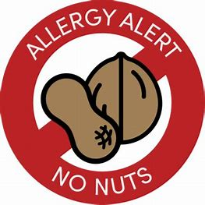  Lunch and snacks | - All pupils in Reception and Key Stage 1 will have a meal in the school hall (Universal Free School meal). Pupils may bring a healthy packed lunch if they wish.  - Nursery pupils are able to purchase a meal or to bring a healthy packed lunch from home, which will be stored in the child’s designated box. This will also be eaten in the hall.  - We are a NUT FREE school. Please do not send your child to school with nut based products.  - Fruit will be provided to all pupils and milk will be provided to all eligible pupils.  - Pupils are not permitted to share any food brought from home with other pupils, this includes treats brought in for birthdays.
Hygiene | - All visits to the toilets are supervised by an adult.  - Regular handwashing is modelled and observed by staff.  - Hand sanitiser is positioned at entry and exit point across the academy and pupils will be supervised when using this.  - Children to bring in their own pack of tissues.  - Enhanced cleaning of resources and environment.  - PPE equipment will be used by staff when necessary.  - We ask parents/carers to wear face covering when dropping off and collecting children due to increased cases locally and nationally.  - If a child falls ill, they will be placed in isolation (and supervised from a safe distance). As a result of a child displaying symptoms their household should self-isolate
Behaviour Policy | - Please check our school website for our new behaviour policy.  - Children will follow the school rules, ‘Be ready, Be respectful, Be safe’ at all times.  - Staff will praise children for following the school rules.
Test and Trace | - As you are aware, the Government are implementing the Test and Trace scheme. If any of our staff are contacted through this service and told to self- isolate, it may be necessary for us to close a bubble at very short notice. This is out of our control, and we will communicate this with parents as soon as we become aware this may happen.
Self-isolating and Home learning | - If at any point your child needs to self-isolate, please make the school office aware immediately. There is a government expectation that children complete the home learning set during this time. Staff will set home learning daily via your child’s portfolio on Class Dojo. Staff will also respond to home learning undertaken via Class Dojo.  - If your child’s bubble needs to self-isolate this will be communicated by school once we are made aware of the positive case. Again home learning will be set daily via your child’s portfolio on Class Dojo. There is a government expectation that this is completed by all children. Staff will respond to learning undertaken via Class Dojo.  - Children should complete home learning in the exercise books that have already been provided.  - If children do not undertake home learning staff will contact parents.
Lateral Flow Test for families | - All adults in households with school and college age children without symptoms can access regular rapid coronavirus testing. This includes your childcare and support bubbles. Tests are fast, easy and completely free.  - This regular testing helps reduce the transmission of the virus as up to 1 in 3 people who have coronavirus have no symptoms.  - Testing is voluntary, but strogly recommended to all who are eligible.  - There are different ways to collect their tests.  - Your employer if they offer testing to employees  - Community testing via an asymptomatic testing site – you can book a test at one of the Stoke-on-Trent’s 17 community venus by going to www.stoke.gov/bookacovid19test  - By collecting a home test kit from a Collection Point – the Governement’s national testing soites in Stoke-on-Trent are Stoke City (Bet 365 Stadium), Synectics Solutions Ltd (beside Port Vale FC) and Fenton Manor Sports Complex. The national testing sites are open each day from 1.30pm to 7pm. You don't need to make an appointment. Please note you shouldn't visit outside of these hours because testing of symptomatic people will be taking place.  - by ordering a home test kit online- you can do this by visiting www.gov.uk/order-coronavirus-rapid-lateral-flow-tests  - You should report your results online straight away, even if your result is negative or void. It’s easy to do at www.gov.uk/report-covid19-result. Results can also be reported via telephone by calling 119 (free from mobiles and landlines). Lines are open every day, 7am to 11pm.  - If you test negative, you can continue to go to work, but you should still strictly follow all other government guideline. If you, your household or bubble test positive, you should all self-isolate immediately. Do not send your child to school if somebody in your household had tested positive. The person who has tested positive should take a confirmatory PCR test by booking though https://www.gov.uk/get-coronavirus-test, or by calling 119 and then follow the NHS Test and Trace guidance.
Communication | - The academy office is accessible via appointment only.  - Class dojo will be the main platform for communication with parents.  - Parents are asked to ensure that they are signed up to Class Dojo before their child comes back to school as this will be our main method of communication.  - If you child is ill, this must be communicated directly to the school office (see attendance policy).

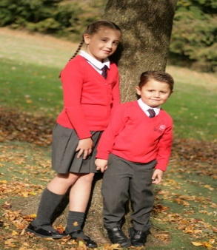  Uniform | PE kits for Key stage 1 children  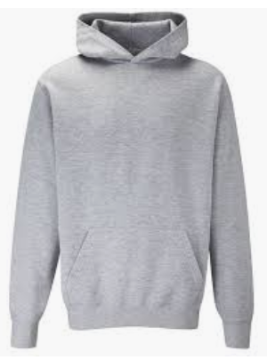  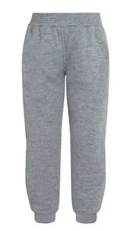 | 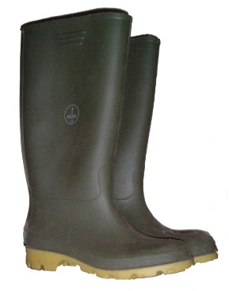  Wellies
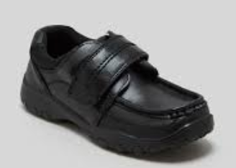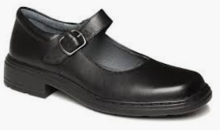  School shoes | 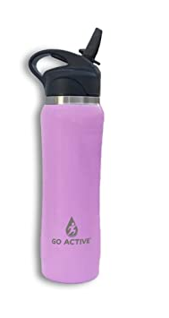  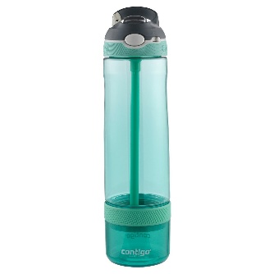  Sports water bottle | 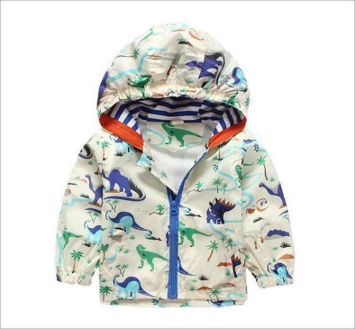  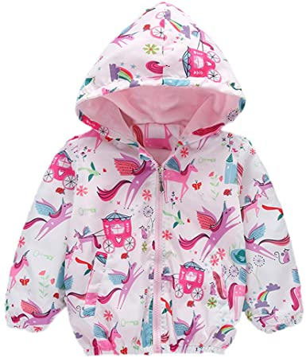  Waterproof coat
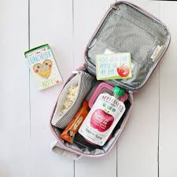  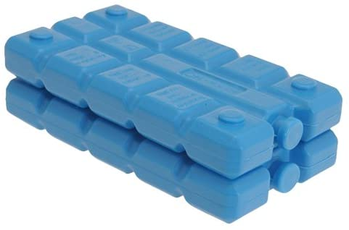  Healthy Lunch & Ice Pack if needed | 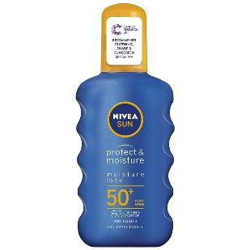  Sun cream | 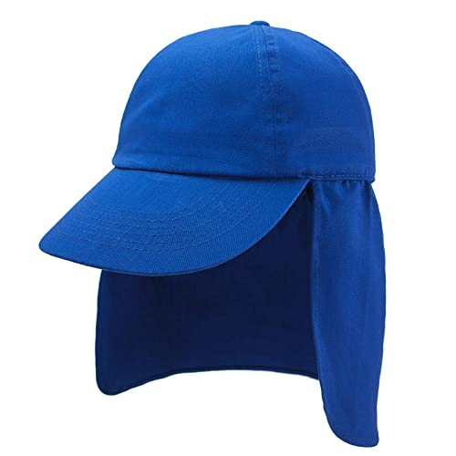  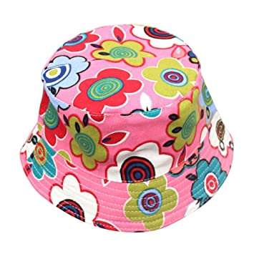  Sun hats

PARENT AGREEMENT:
I AGREE THAT I WILL FOLLOW THE GUIDANCE BELOW:

- Update school immediately if a member of my household becomes ill and immediately follow the self-isolation expectations of 10 days for the infected member of my household and 10 days for all other members of the household.
- Should my child become unwell, with Coronavirus symptoms, I will obtain a test via 119, keep my child (and any siblings) at home whilst I await the results and inform the school as soon as possible of the test result. If I do not get my child tested, I will self-isolate my child for 10 days (10 days for any siblings) before I bring them back to school.
- Explain clearly to my child what social distancing is and why it is important for it to take place at school (where possible). Pre discuss with my child that things may be different to what they remember.
- Ensure my child arrives promptly and is collected promptly at the times identified above. (I understand that staff will follow their attendance processes and may discuss my child’s absence and punctuality with me). If I miss my child’s entry time, I know I will need to wait until the end of the allocated times for all bubbles.
- Allow my child’s temperature to be taken with a thermometer if they begin to show any signs of Coronavirus.
- Ensure my child wears their clean school uniform and school shoes each day.
- Ensure that my child does not wear earrings to school.
- Ensure my child brings coats and wellies OR a sun hat and sun cream, so they can access outdoors in all weathers.
- Ensure my child brings their inhaler (which will be kept in school) and any other prescription medication/creams daily if required. (Only medication or cream prescribed from a doctor will be applied).
- Ensure up to date contact details for family members are available within school and emergency contact details should my child become poorly/exhibit symptoms of contracting coronavirus.
- Treat staff with respect at all times.
- Ensure I observe the social distancing markers during arrival and dismissal.
- Ensure I wear a face covering at all times whilst on site (unless exempt).
- Ensure I do not gather with other parents/carers on the school gate.
- Ensure I do not enter the school building without a pre-arranged appointment.
- Ensure I communicate with class teachers through Class Dojo.
- Ensure my child brings their own packed lunch (if they are not eligible for a universal free school meal or free school meal), in a clearly labelled lunch box and include an ICE PACK to keep the lunch cool and any cutlery needed.
- Ensure I adhere to all of the expectations outlined in this document.

A message from Northwood Broom staff
Get your uniforms ready it's back to school for everyone on Monday 8th March! We cannot wait to see you all face to face in school again.
Please be assured that we have worked hard on all of the arrangements, in line with the updated Government guidance, to ensure everyone is kept safe. We will continue to deliver the very best education to your children both in school and remotely (if self-isolating or in the event of a bubble closure). Thank you so much for your support in implementing our safety measures. It really is appreciated, particularly now, as we are reopening school to all pupils.
As always, should you have any questions, recommendations or solutions we would love to hear from you.
Stay safe and well – your support is immensely appreciated.

Mrs Moran, Mrs Glaister and Mrs Brandrick and all the Northwood staff xxx

Coronavirus related absences- quick reference guide (06.08.2020)
What to do if… | Action needed | Register Code | Return to school when…
…my child has coronavirus symptoms | - Do not come to school  - Contact school daily  - Self-isolate  - Get a test  - Inform school immediately about test result | X | …the test result comes back negative and you now feel well. Remain at home if symptoms persist
…my child tests positive for coronavirus | - Do not come to school  - Contact school daily  - Self-isolate for at least 10 days  - Inform school immediately about test result | I | …the 10 days has expired and the child feels better. They can return to school after 10 days even if they have a cough or loss of smell/taste as these symptoms can last for several weeks once the infection is gone.
…somebody in my house  has coronavirus symptoms | - Do not come to school  - Contact school daily  - Self- isolate  - Household member to get tested  - Inform school immediately of test result | X | …the household member  test is negative
…somebody in my household has tested positive for coronavirus | - Do not come to school  - Contact school daily  - Self-isolate for 10 days | X | …the child has completed  10 days of self-isolation
…NHS test and trace have identified my child as  ‘close contact’ of  somebody with symptoms or confirmed coronavirus | - Do not come to school  - Contact school daily  - Self-isolate for 10 days | X | …the child has completed  10 days of self-isolation
My child has had ‘close contact’ with someone who received a positive test result | - Do not come to school  - Contact school daily  - Self- isolate for 10 days from the date of your last contact with the person | X | …the child has completed 10 days of self- isolation
…we/my child has travelled and has to isolate as part of a period of quarantine | - Do not take unauthorised leave in term time  - Consider quarantine requirements and FCO advice when booking travel  - Provide information to school as per attendance policy  Returning from a destination where quarantine is needed:  • Do not come to school  - Contact school daily  - Self-isolate for 10 days from date of return to UK | X | …the quarantine period of  10 days has been completed
…we have received medical advice that my child must resume shielding | - Do not come to school  - Contact school as required by the admin team  - Shield until you are informed that restrictions linked to shielding is paused again | X | …you are informed that restrictions have been lifted and your child can return to school again
…my child is unwell with symptoms NOT related to  coronavirus | Follow the usual procedures as per the attendance policy  • Contact the school daily | I  (unless medical evidence requested) | …the child feels better again

